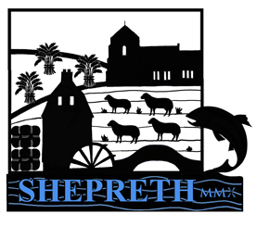
Shepreth Annual Parish Meeting
Monday 27th March 2023 at 7.30pm
at Shepreth Village Hall

Parishioners, members of the public and the press are welcome to attend this meeting.

Mr Nick Downer – Chairman to Shepreth Parish Council

22nd March 2023

Agenda
- Introduction by the Chairman Cllr Nick Downer
- Apologies for absence
- To approve the Minutes of the Annual Parish Meeting 2022 (circulated previously)
- Parish Council accounts will be presented at the Annual Meeting of the Parish Council on 15th May 2023
- Chairman Cllr Nick Downer will give a report from the Parish Council over the past year and will take any questions on Parish Council business.
- Reports from County Councillor Peter McDonald and District Councillors Jose Hales and Sally Ann Hart
- Shepreth Spitfires presented by Lucy Smith
- Shepreth School Trust presented by Charles Cook
- Shepreth Parochial Church Council presented by the Clerk
- Shepreth Relief in Need Charity
- Shepreth Village Hall presented by Nick Mann
- Happy Bunnies presented by Robert Fox
- Shepreth Women’s Institute presented by Caroline Pepper
- Friends of the River Shep presented by Steven Swain
- Melbourn Area Youth Development (MAYD) – presented by Cllr Cartmell
- Melbourn, Shepreth & Foxton Rail User Group and Community Rail Partnership – reports on all of these by Susan van de Ven
A10 Corridor Cycling Campaign - reports by Susan van de Ven & SCWAG report
- Cllr John Fisher on Energy saving initiatives for Shepreth
- Cllr Chris O’Brien on engaging the community of Shepreth
- OPEN FORUM – ask questions on matters that affect you and your village and local community.

